Deploy a 3 tier Fullstack app with python backend + RDS cache

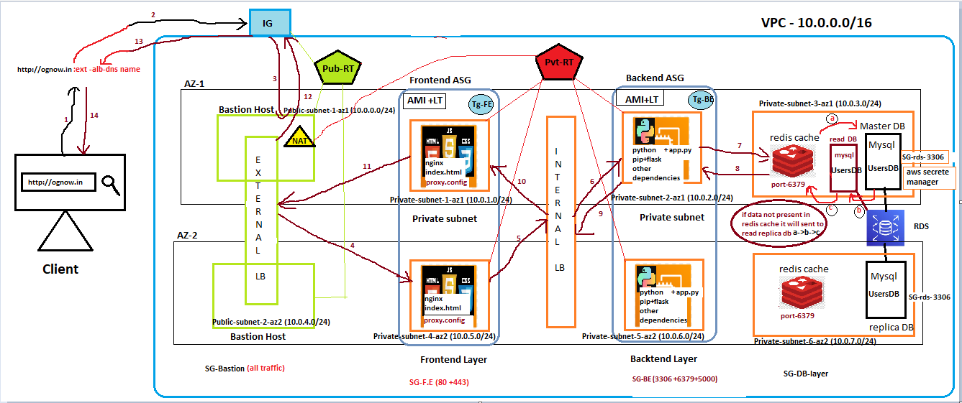
Prerequisite
- VPC (10.0.0.0/16)+IG+NAT
- 2 availabaility zone (AZ-1 +AZ-2)
- Create total 8 subents (4 for each az)
- Az1 (1 public +3private)
- Az2 (1 public +3 private)
- 2 bastion host + 2 pvt frontend server + 2 pvt backend server)
- RDS users DB +( 1 RDS master in az1 + 1 RDS replica in az2
- Public-RT + Private-RT
- 1 FE-ASG (AMI + LT) + 1 BE-ASG (AMI +LT).
- 1 Internal ALB (BE-Tg1)+ 1 External ALB (FE-Tg1).
- AWS secrete manager + IAM role
- Get all required resources from – https://github.com/itmukesh-16/python-backend-testing.git

Az1 Az2

Public → 10.0.0.0/24 Public-subnet-1-az1 Public → 10.0.4.0/24 Public-subnet-1-az2
Frontend → 10.0.1.0/24 Private-subnet-1-az1 Frontend → 10.0.5.0/24 Private-subnet-4-az2
Backend → 10.0.2.0/24 Private-subnet-2-az1 Backend → 10.0.6.0/24 Private-subnet-5-az2
DB → 10.0.3.0/24 Private-subnet-3-az1 DB → 10.0.7.0/24 Private-subnet-6-az2

Implementation
Infrastructure & Network Set up-
- Create VPC (10.0.0.0/16) and attach IG and NAT
- Connect Public-RT to IG and Private-RT to NAT (Make sure the NAT connected to one of the public subnet for internet supply and while creating select Regional option)
- Connect Public-RT Public subnet , Private-RT Private subnets.
- Create 4 SGs, as of now give all access from anywhere for all SGs ( SG-Bastion , SG-FE , SG-BE , SG -DB) .letter we can open required port only
[create initially one bastion host , check IG connection and deploy 1 private server , check NAT connection] once success fully tested the connection go to the next phase.
RDS database set up -
- Create sone RDS subnet group .
- Deploy 1 RDS DB named usersDB in az1 private subnet (Enable aws managed secrete keys )
- Test connection to RDS DB using mysql workbench via Bastion Host.(mysql workbench bastion host RDS DB ) .
- Now create 1 replica usersDB in az1 +1 replica usersDB in az2 (test connection for read DB deployed in both AZs.)
- Create a redis cache for Masterdb (usersDB).make sure the SG attached to cache db opens port 6397
Backend setup –
- Deploy Backend-az1 server in private-backend-subnet ,check internet connectivity
- Connect Frontend server in az1 and switch to root user
- install [ python+pip+mariadb105]
- Create a directory backend -> then create backend.py ,requirements.txt , usersdb.sql .
- requirements.txt {flask + flask-cors + mysql-connector-python + redis + cryptography + pymysql+boto3}
- under usersdb.sql give users table schema.
- Using mariadb105 (mysql agent) test connection to RDS usersdb .(for private server to RDS usersdb)

[at the RDS time, if RDS credentials – self managed ]

To execute sql query by staying in the backend private server
#mysql –h <endpoint dns> -u admin –p’dbpassword’ < usersdb.sql

To manage rds usersdatabase in the backend
#mysql –h <endpoint dns> -u admin –p

[if the RDS creation time , RDS credentials managed by – aws secrete manager , then we need to create an IAM role with permission (SecretsManagerReadWrite) and add it to backend server .otherwise it wont allow to acces]

- Include backend code in backend.py then run #python3 backend.py
- For temporary fetch the result , open new terminal then check process(ps aux | grep python) and port( ss -tuln) ,whether the python service is running or not if running then fetch user data from usersdb by –

- curl -X GET http://localhost:5000/users
if there is no out put or you get request : timed out ,it means EC2 is not able to connect to the cache database .(check if SG of redis cache allowing 6379 , subnet , VPC )

- to effieciently handle the process in the same server ,you can configure #pm2 for prcess to run.
- Then #systemctl enable python3 backend.py
Frontend Set up-
- Create Frontend server in az1 , connect and switch to root
- Configure (nginx +index.html +proxy.conf)
- Install nginx and replace frontend code in /usr/share/nginx/html/index.html
- Configure index.html , make sure the front end code satisfy the structure which will present the data fetched from the backend.otherwiser it wont show in broweser
- Configure proxy.conf file to support reverse –proxy ie redirect the request from external ALB frontend server internal ALB.
- #yum install nginx -y
- #sudo vi /etc/nginx/conf.d/reverse-proxy.conf
- #sudo nginx -t
- #sudo systemctl reload nginx

- Now run #systemctl start nginx
- Again #systemctl enable nginx
- For testing ,try to fetch the data from backend
# curl -X GET http://backend-server-private-ip:5000/users
If its fetching data it means it successful.api and index page is working

Create AMI and Launch Template –
[Before creating LT , make sure the Frontend and backend services are running ie nginx , python . also make sure you configured the services in such a way it will autostart the services everytime there is a reboot , deploy new instance,system chrash or new session
For ex nginx #systemctl enable nginx ]
- Select Frontend-az1 server >AMI>Launch Template (select desired vpc,subnets azs for deployment)>Frontend-LT
- Using Frontend-LT deploy another frontend server in Private-subnet-4-az2.
- Then do for Backend-az1 server>AMI>Launch Template>Backend-LT
- Using Backend-LT deploy another frontend server in Private-subnet-4-az2.

Configure Load Balancer
Internal load balancer for Backend server HA:
  - Create a target group BE-Tg1(select the two backend server from both AZs)
  - Give path ‘/’, http(80) protocol and port :5000 (cause python flask running on port 5000) and it will check the port health to distribute the traffic.
  - Now create an application load balancer(ALB) internal-facing configure port 5000.
  - Add target group BE-Tg1 and create internal load balancer internal-dns.
  - Now for test fetch the data using internal-alb-dns from frontend server.
# curl -X GET http://internal-alb-dns:5000/users

    - If the test successful.then update the internal-alb-dns link in revers_proxy.conf file of the both frontend servers.
    - Otherwise the frontend will always point to fixed private backend server ip ,as a result the load balancer will not work properly
    - Also update Frontend-LT or else it will contain the old server configuration and will cause issue in ASG .

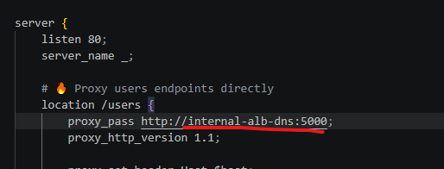
External/Internet load balancer for Frontend server HA:
- Create a target group FE-Tg1(select the two backend server from both AZs)
- Give path ‘/’, http protocol and port :80 (cause nginx running on port 80) and it will check the port health to distribute the traffic.
- Now create an application load balancer(ALB) External-facing configure port 80.
- Add target group FE-Tg1 and create External load balancer Ext-alb.
- Now access the External-alb-dns in browser and see if the the index page is properly working or not .
Now create ASG-
[make sure the Launch Template you providing to ASG has latest/updated configuration of running instances ,otherwise it will not deploy the updated instance configuration and services running inside the servers . As a result , it might not give expected result ]
- Configure Frontend -ASG for Frontend server HA
- Configure Backend – ASG for backend server HA
For testing purpose lower the cpu utilisation threshold and see if the autoscalling is working or not.
Now configure SGs-
Since we had opened all the ports for all the sercurity groups for testing and its not recommended .it may cause security breach .
Hence only open required inbound and outbound ports for all the SGs
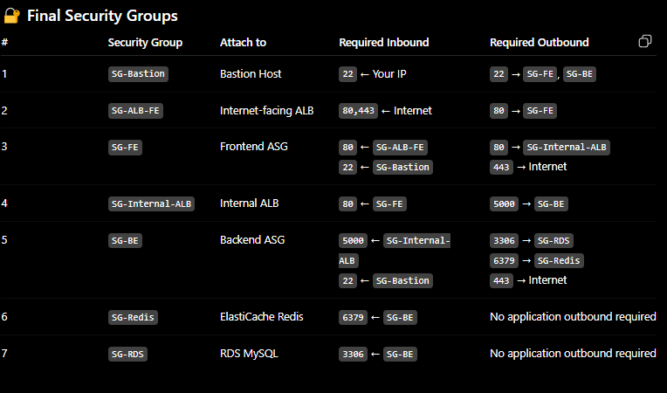

Task Over

